How do acquire and deploy your Nessus scanner:  
  
<https://www.tenable.com/products/nessus/nessus-essentials>  
  
Look at your email:  
  
Now let’s deploy it in the AWS Account:  
  
Look for Tenable Core + Nessus (OL8)

You will need to subscribe to it before being able to use it, *I will need a fresh account to take prints*

Select the smallest possible Instance: (t3.xlarge)

Chose a Key Pair that you have access to it, as you will need it to set the Administrative password

Select the Public Subnet to host this EC2 and assign a public IP to it, you will need to connect to the UI later.

Create the following Security group and tie it to your IP

Launch the instance

Look for the Nessus Core instance:  
  
  
Click on connect to get the SSH string and change the user to ec2-user and the Key pair name to yours:  
  
  
ssh -i "Cora2025.pem" ec2-user@ec2-3-131-115-236.us-east-2.compute.amazonaws.com

Run the following command and create your own password:  
  
sudo passwd "$USER"  
  
Login to the Web UI:  
  
Go to Nessus and click on the URLs:

Activate your License.

When you log into Nessus Essentials for the first time you will need to wait for the plugins to be updated, this can take 30-60 minutes.  
After the plugins are fully updated, you will be able to start your scan.

Click on + New Scan

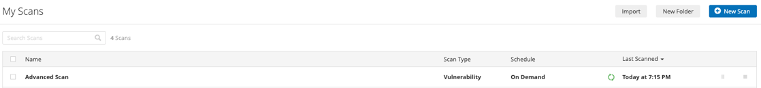

Chose Advanced Scan

Give a name to the scan and set your VPC CIDR to be scanned and click launch

DOCS:  
  
<https://docs.tenable.com/integrations/AWS/Content/Welcome.htm>